**SQL Assignments - Set 1**

1. Display the records of job clerk and manager for deptno 20.

Select * From Emp

Where (Job = 'Clerk'

Or

Job = 'Manager')

And

Deptno = 20;

1. Display the records for the employees, which have the last character as R or H in their name.

Select * From Emp

Where Ename like '%R'

Or

Ename like '%H';

1. Display the records of the employees earning sal less than 1000 and there is no comm provided.

Select * From Emp

Where Sal < 1000

And

Comm is null;

1. Produce the following output:

Details

-----------------------------------------------------------------------

SMITH is from the deptno 20, earns salary 800

ALLEN is from the deptno 30, earns salary 1600

WARD is from the deptno 30, earns salary 1250

JONES is from the deptno 20, earns salary 2975

MARTIN is from the deptno 30, earns salary 1250

BLAKE is from the deptno 30, earns salary 2850

CLARK is from the deptno 10, earns salary 2450

SCOTT is from the deptno 20, earns salary 3000

KING is from the deptno 10, earns salary 5000

TURNER is from the deptno 30, earns salary 1500

ADAMS is from the deptno 20, earns salary 1100

JAMES is from the deptno 30, earns salary 950

FORD is from the deptno 20, earns salary 3000

MILLER is from the deptno 10, earns salary 1300

Select Concat(

Ename , " is from the deptno " , Deptno , ", earns salary" , Sal ) as "Details"

From

Emp;

1. Display the ename, sal, comm, sal+comm. For the null value of commission 10% of sal should be used.

Select Ename,

Sal,

Comm,

Sal+Coalesce(Comm,Sal*0.1) as "Total"

From

Emp;

1. Display the names, sal, job, deptno and raise in the salary.

The raise is to be given under following scenarios –

1. Employees from deptno 20 from job Clerk should get 30% raise in their salary.
2. Employees from deptno 20 from job Analyst should get 50% raise in their salary.
3. Employees from deptno 30 from job Manager should get 60% raise in their salary.
4. Employees from deptno 30 from job Salesman should get 70% raise in their salary.
5. Employees from deptno 10 from job Clerk should get 10% raise in their salary.
6. The remaining employees should get the raise of 500.

Select Ename,

Sal,

Job,

Deptno,

Case

When Deptno=20 And Job='Clerk' Then Sal*0.3

When Deptno=20 And Job='Analyst' Then Sal*0.5

When Deptno=30 And Job='Manager' Then Sal*0.6

When Deptno=30 And Job='Salesman' Then Sal*0.7

When Deptno=10 And Job='Clerk' Then Sal*0.1

Else

500

End as "Hike"

From Emp;

1. Display the records of employees from the job Clerk earning salary above 1000 as well as all Managers earning salary above 2900.

Select *

From Emp

Where (Job = 'CLERK' And Sal >1000)

Or

(Job = 'Manager' And Sal > 2900);

1. Display the records sorted as per the job. Make sure that within each job the records are sorted as per the highest to lowest commissions.

Select *

From Emp

Order By Job , Comm desc;

1. Display name, salary, 30% of salary as tax and salary – tax as take home salary for records of employee table working in deptno 20.

Select Ename,

Sal,

Sal*0.3 as Tax,

Sal-Sal*0.3 as Home_Salary

From Emp

Where Deptno = 20;

1. Display records from emp table of all Salesman from deptno 20 only.

Select *

From

emp

Where

Job = 'Salesman'

And

Deptno = 20;

1. Display records from emp table of all those employees who are not reporting to anyone.

Select *

From

emp

Where

Mgr is NULL;

1. Display records from emp table of those employees who are earning salary less than or equal to 2000. Records should be sorted as per deptno, and within deptno as per their salaries highest to lowest.

Select *

From

Emp

Where

Sal <= 2000

Order By Deptno,Sal Desc;

1. Display Name, Salary, Commission and Total as Salary + 30% of Commission for all those employees whose difference between Salary and Commission is less than or equal to 1200.

Select Ename,

Sal,

Comm,

Sal+Comm*0.3 as Total_Salary

From Emp

Where Sal-Comm <= 1200;

1. Produce the exact same output as shown below:

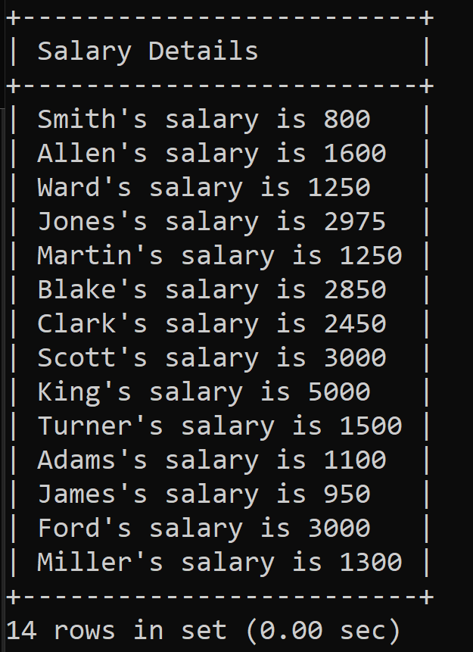

Select Concat(

Substring(Ename,1,1), lower(Substring(Ename,2)), "'s salary is " , Sal ) as "Salary Details"

From

Emp;

1. Execute the following SQL script:

create table Asia

(TrID Integer **Not** **Null**,

Country Varchar(20) **Not** **Null**,

PName Varchar(40),

Amount Integer **Not** **Null**,

DOT Date)**;**

**Insert** **into** Asia **Values**(1,'India','Laptop', 25000, '2017-03-17')**;**

**Insert** **into** Asia **Values**(2,'India','Mobile', 10000, '2018-02-21')**;**

**Insert** **into** Asia **Values**(3,'China','Laptop',15000 , '2017-10-04')**;**

**Insert** **into** Asia **Values**(4,'China','Mobile',80000 , '2018-01-10')**;**

**Insert** **into** Asia **Values**(5,'Singapore','Laptop',90000 , '2017-07-11')**;**

**Insert** **into** Asia **Values**(6,'Singapore','Mobile',18000 , '2018-02-25')**;**

**Insert** **into** Asia **Values**(7,'Malaysia','Laptop',12000 , '2017-05-29')**;**

**Insert** **into** Asia **Values**(8,'Malaysia','Mobile',28000 , '2018-03-19')**;**

**Insert** **into** Asia **Values**(9,'India','Laptop', 14000, '2017-04-11')**;**

**Insert** **into** Asia **Values**(10,'India','Mobile', 70000, '2018-03-24')**;**

**Insert** **into** Asia **Values**(11,'China','Laptop',25000 , '2017-10-06')**;**

**Insert** **into** Asia **Values**(12,'China','Mobile',19000 , '2018-01-15')**;**

**Insert** **into** Asia **Values**(13,'Singapore','Laptop',100000 , '2017-06-14')**;**

**Insert** **into** Asia **Values**(14,'Singapore','Mobile',35000 , '2018-02-27')**;**

**Insert** **into** Asia **Values**(15,'Malaysia','Laptop',43000 , '2017-08-21')**;**

**Insert** **into** Asia **Values**(16,'Malaysia','Mobile',45000 , '2018-03-19')**;**

Question 🡪 Display India records of year 2018 of Amount > 15000, China records of year 2018 of Amount < 20000 and Singapore records of year 2018 of Amount > 40000.

Select *

From

Asia

Where (Country = 'India' and year(Dot) = 2018 and Amount > 15000)

Or

(Country = 'China' and year(Dot) = 2018 and Amount < 20000)

Or

(Country = 'Singapore' and year(Dot) = 2018 and Amount > 40000);